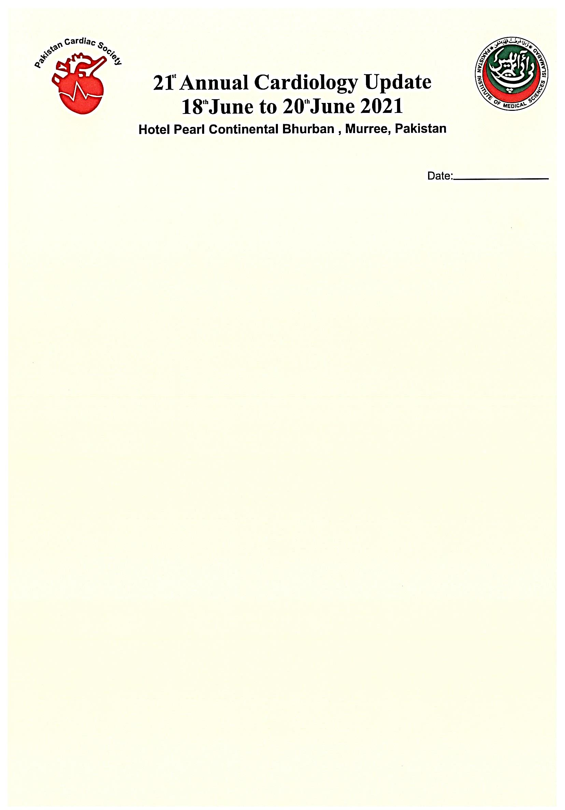

**----------------------------I n c o l l a b o r a t i o n w i t h -------------------------** Pakistan Institute of Medical Sciences, Islamabad

Annual cardiology updates are held at Bhurban every year, where invited guest speakers from all over the country, and abroad talks about a particular aspect of the cardiovascular diseases.

After the very successful previous conferences, the 21st Annual Cardiology Update would be held on 18th to 20th June 2021 at Pearl Continental Hotel, Bhurban, Murree. All the prominent cardiologist and physicians from all over the Globe would attend.

This would be an excellent opportunity for you to interact with all these busy cardiologists and physicians in the relaxed atmosphere of Bhurban. We offer you the following:

* Stalls at the exhibition area.
* Hospitality suites.
* Lectures by experts.
* Prize for the delegates.
* Sponsored dinner/ lunch/ tea symposium.
* Social evening during the conference.
* Sponsorship of speakers, chairperson and delegates.
* Any Donations, Bags, Shields, Backdrops, Poster, Printing.

You are requested to confirm your participation before 30th April 2021. Please refer to the tariff overleaf and make your bank drafts payable to “21st Annual Cardiology Update”.

We look forward to your continuous cooperation.

Yours sincerely,

**Akhtar Ali Muhammad Shafique Arshad Fazlul Aziz Mian Muhammad Naeem Malik**  **Convener Chairman Secretary Patron**

**CONFERENCE SECRETARIATE  
Department of Cardiology  
Pakistan Institute of Medical Sciences, Islamabad  
Ph: # +92-51-9260330 Email:** [**cardiologyupdate21@gmail.com**](mailto:cardiologyupdate21@gmail.com) **Whatsapp Group: cardiology update, whatsapp # +92 321 5034320**

|  |
| --- |
| **TARIFF**  Stall at the exhibition area …………… Rs 800,000  Hospitality Suite …………………………… Rs 1,200,000  Hospitality in Rooms ……………………. Rs 800,000  Donation ……………………………………… Any Amount  Qty. of Bags …………………………………. 350  Lunch/ Dinner/ Tea/ Breakfast/ Sponsored Symposium to be Negotiated  **BANNERS IN SYMPOSIUM HALL**  Left side of wall ………………………………..Rs 1,000,000  Right side of wall ……………………………… Rs 1,000,000  Front side of Wall …………………………….. Rs 600,000 |

P.S. These charges are exclusive of income tax deductions and bank fee. Please make your bank draft payable to 21st Annual Cardiology Update.